Introduction to Data Structure

Data Structure is a way of collecting and organising data in such a way that we can perform operations on these data in an effective way.

We can organize this data as a record like Player record, which will have both player's name and age in it. Now we can collect and store player's records in a file or database as a data structure. For example: "Dhoni" 30, "Gambhir" 31, "Sehwag" 33

Basic Types of Data Structure

Primitive Data Types :

Abstract Data Structure/ Non Primitive Data Types :

Primitive Data Types :

System /Compiler defined data type are called primitive data types.

Example:

Integer, float, boolean, char etc.

Primitive Data types support basic operation like addition, subtraction etc.

Abstract Data Structure/ Non Primitive Data Types :

The data types that are derived from primary data types are known as non primitive data types. The non primitive data types are used to store the group of values.

Example : Array , link list, stack, queue, graph, tree etc.

They are consists

Data Structure

Set of Operation

Continued…
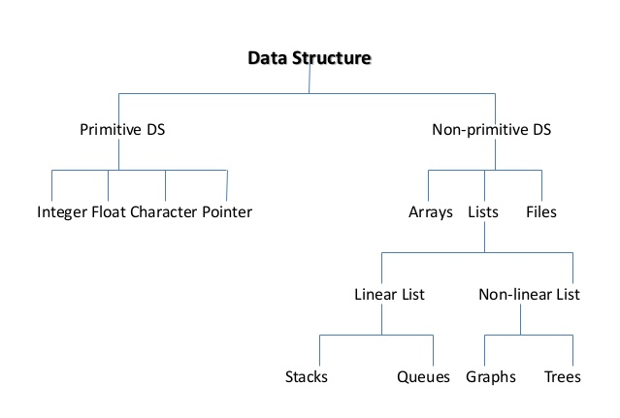
Assignment : Difference between Linear and Non Linear data structure.

Algorithm
An algorithm is the step by step instruction to solve a given problem.
Example : Sum of n natural number.
The permormance of an algorithm is measure on the basis of the following properties.
Time Complexity
Space Complexity
- Time Complexity is a way to represent the amount of time needed by the program to run to completion.
- An algorithm generally requires space for following components.
- Instruction Space: It’s the space required to store the executable version of the program. This space is fixed, but varies depending upon the number of line of code in the program.
- Data Space: It’s the space required to store all the constants and variable value.
- Environment Space : It’s the space required to store the environment information needed to resume the suspended function.

Rate of Growth
The Rate at which the running time increases as a function of input is called rate of growth.
f(n)= n⁴ + 2n² + 100n + 500 //Time after value n
f(n) = n⁴ for some n where n>n₀ (particular value)
Neglect : Hardware or Environment Time

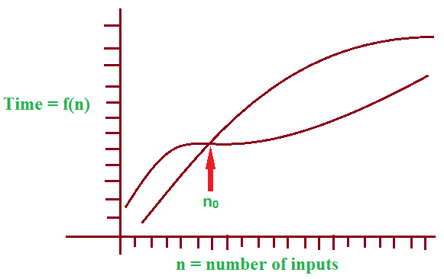

Types of Analysis
To analyze the given algorithm we need to know an what inputs the algorithm is taking less time and on what inputs the algorithm is taking huge time.
Worst Case
Average Case
Best Case
// Use for compare two algorithm in all case
Example: Numbers Arrange in ascending order.

Asymptotic Notations
For all the three cases we need to identify the upper and lower bounds
Syntax to representations of bounds are
- Big-Oh O notation
- Omega Ω notation
- Theta $θ$ notations
Purpose : Comparison between two algorithms
Example : We have Problem A and B
A =O(B) //A<=B
A = Ω (B) //A>=B
A = $θ(B)$ //A==B
Conclusion : Notations gives a Boundaries like Lower, Upper and Equal.
Imp Terms : Function may be +ve or –ve
Example :
+ve : n-100 , n-1000
-ve : 100 – n
What is the Best Case and Worst Case ?
Best Case : Every attempt success will occur
Minimum No. of Attempt
Theta $θ$ notations Gives minimum Boundaries
Worst Case : Every Attempt failure will Occur
Maximum No. of Attempts.
Big-Oh O notation gives Maximum Boundaries
Examles:
We have 4 Black Shocks and 4 White Shocks
We want to get one Pair of Shocks.
In Best Case: B B
Worst Case: B W B/W Or W B B/W
Asymptotic Analysis
Big-Oh Notation
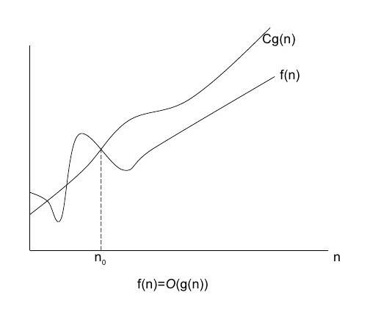
Let f(n) and g(n) be 2 +ve functions
F(n) = O(g(n)) Or F(n) is Big Oh of g(n)
Iff f(n)<= c.g(n) for all n, n>0

Where n is a +ve integer and n>= n₀ and c is the constant (c>0 , n>0)
Note : n₀ is Particular value of n.

Example 1
F(n) = 2n
G(n) = n
F(n) = O(g(n))
2n <= c. n
Remember : Get Value of c is minimum as possible , first increase n then c
Sol : When n₀=1 and c=2
Example 2
F(n) = n+10
G(n)=n
F(n) = O(g(n))
N+10 <= cn
Sol : n₀=10 & c=2
10+10 <= 2*10
Example 3
F(n) = n
G(n) = n + 10
F(n) = O(g(n))
n<=c(n+10)
Sol : Yes, When n₀= 1 , c = 1
Example 4:

f(n) = n²
g(n) = n
f(n) = O(g(n))
n² = O(n)
n² <= n
n²<= c.n
Sol : No , and also we cannot take c=n, because c is constant value not an exponential, So it is not satisfy
Example 5 :
F(n)=n² + 3n +1
G(n) = 2n²
n² + 3n +1 = 2n²
Sol : When n₀₌ 4 , c=1
Example : 6 :
F(n) = 3n + 2
G(n) = n
Sol : When n₀₌ 2 , c = 4
Example 7:
F(n) = 2n+1
G(n) = n
F(n) = Og(n)
2n+1 = n
When n₀ = 1, c=3
Omega Notation
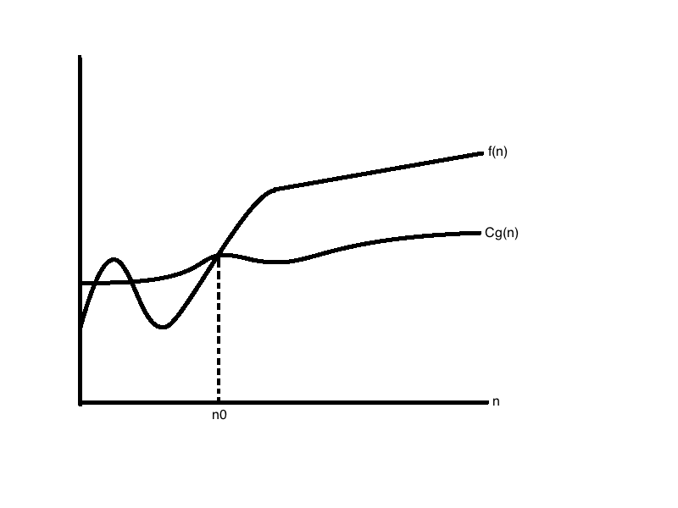
F(n) = Ω g(n) Or F(n) is omega of g(n)
iff
F(n) >= c.g(n)
Where n is a +ve integer and n>= n₀ and c is the constant (c>0 , n>0)
Note : n₀ is Particular value of n.
Example 1:
F(n) = n
G(n) = n+10
F(n) = Ω(g(n))
n>=c(n+10)
Sol : Yes ,When n₀= 10 , c=1/2

Example 2:
F(n) = n+10
G(n) = n
F(n) = Ω g(n)
n+10 >= cn
Sol : Yes , When n₀= 1 , c =1
Example 3:
F(n) = n
G(n) = n²
F(n) = Ω(g(n))
n>=c n²
Sol : No, We cannot put c=1/n because c is represent only constant value.
Example 4 :
F(n) = n²
G(n) = n
Sol : Yes, When n₀=1 , c=1
Example 5 :
F(n) = n²
G(n) = n²
Sol : Yes When n₀ =1, c= 1
Example 6:
F(n) = n²
G(n) = n²
Sol : Yes , When n = 1, c = 1
Example 7 :
F(n) = n²/2
G(n) = n²
Sol : Yes , When n₀ = 1, c= 1/4
Example 8
F(n) = n
G(n) = n²
Sol : No

Theta Notation
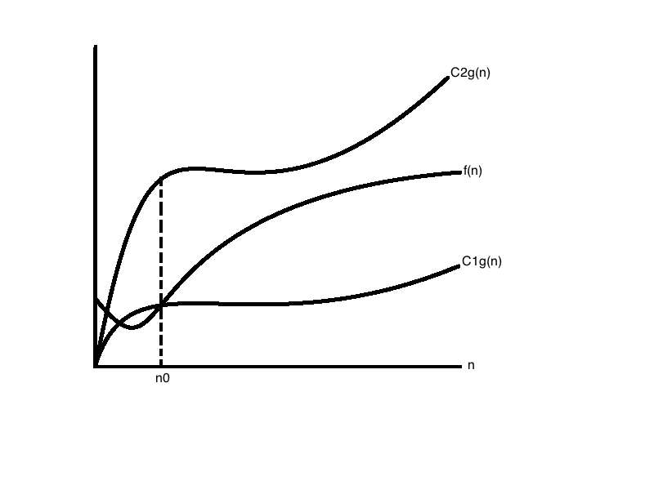
F(n) = $θ$ g(n)
F(n) is theta of g(n)
iff
F(n) <=c1.g(n)
F(n) >= c2.g(n)
Where n is a +ve integer and n>= n₀ and c1 and c2 is the +ve constant (c>0 , n>0)
C1 and c2 may not be the same positive constants.
Note : n₀ is Particular value of n.
Example 1:
f(n) = n+ 10
g(n)=n
f(n)=$θ$ g(n)
- F(n) <=c1g(n) //n+10 <= c1n
- F(n)>=c2g(n) //n+10>=c2n
n+10 <= c1n
c1 = 2
n₀ = 10
n+10>=c2n
c2 = 1
n₀ = 1
f(n) = Og(n) ,c1=2
f(n) = Ω g(n) ,c2=2
For n₀ >10
Note: Always take large n₀.

Example 2.
F(n)= 2n + 8 and g(n) = n
c1*g(n)<= f(n)
When c1 = 5 , n =2
f(n)<= c2*g(n)
When c2 = 7 , n =2

